**1. Algorithm**

Algorithm is a step by step procedure for solving a computational problem.

**2. Program**

Program is a step by step procedure for solving a problem.

**3. Algorithm vs Program**

**3.1 What are the Software Development Life Cycle (SDLC) phases?**

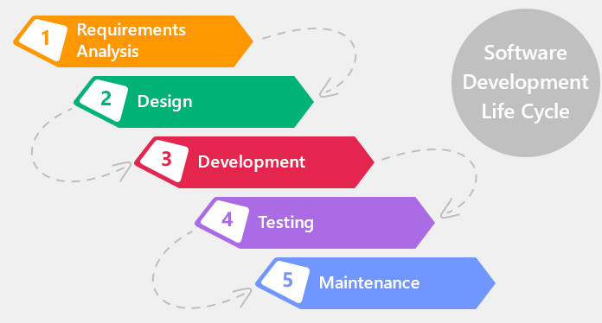

**Algorithms** are written at design phase & designer should have domain knowledge.

* Designer can use any language to write algorithm like mathematical notations, english language & …
* Designers write algorithm & the programmer write a program for it.
* [hardware and software independent] - when writing algorithm, it is not necessary to know the hard ware and software, like what machine and what operating system is used.
* Finally analyse the algorithm

**Programs** are written at development phase.

* [hardware and software dependent] - writing program is dependent on hardware and software.
* Finally test the program